Analysing Housing Prices in Metropolitan Areas of India

Group Members

L.Hari Prasath

P.Yoga tharshini

M.Puniyhavathy

M.Ponraj

C.Esakki Muthu

Project Report:

House price prediction in a metropolitan city in India is a valuable solution for potential home buyers, real estate agents, and investors. By leveraging historical sales data, property details, and location-specific information, a predictive model can accurately estimate house prices. The model's scalability, real-time updates, user-friendly interface, and transparency ensure it meets the needs of stakeholders. Integration capability, data privacy, and cost-effectiveness are also important considerations. By addressing these requirements, the prediction model provides reliable insights, empowering stakeholders to make informed decisions in the fast-paced real estate market

1. **Data Collection**:
   * Gather data on housing prices in the metropolitan areas you want to analyze. This data can be obtained from real estate websites, government agencies, or local real estate agents. Ensure that the data is up-to-date and comprehensive.
2. **Data Preprocessing**:
   * Clean the data to remove outliers, missing values, and inconsistencies.
   * Normalize or standardize the data if necessary to make comparisons easier.
3. **Feature Selection**:
   * Identify relevant features that affect housing prices. This can include location, square footage, the number of bedrooms and bathrooms, property age, amenities, and more.
4. **Exploratory Data Analysis (EDA)**:
   * Conduct EDA to gain insights into the data. Visualizations, such as histograms, box plots, and scatter plots, can help you understand the distribution and relationships between variables.
5. **Geospatial Analysis**:
   * For metropolitan areas, geographic location is often a critical factor. Use geospatial tools and maps to analyze how housing prices vary across different neighborhoods and districts within the metropolitan area.
6. **Time Series Analysis**:
   * Analyze housing price trends over time. Are prices increasing, decreasing, or remaining stable? This can help in understanding market dynamics.
7. **Regression Analysis**:
   * Use regression techniques to model the relationship between housing prices and various factors. Multiple linear regression or more advanced methods like machine learning models can be employed.
8. **Hedonic Pricing Model**:
   * Consider using a hedonic pricing model, which breaks down the price into its components, such as location, size, age, and amenities. This can help you quantify the impact of each factor on housing prices.
9. **Market Demand and Supply**:
   * Understand the demand and supply dynamics in the metropolitan area. Changes in the number of properties available and the demand for housing can greatly influence prices.
10. **Economic and Demographic Factors**:
    * Consider the economic health and demographic trends of the metropolitan area. Factors such as job opportunities, population growth, and income levels can affect housing demand and, consequently, prices.
11. **Government Policies**:
    * Be aware of any government policies and regulations that may impact the housing market, such as tax incentives, zoning laws, or building codes.
12. **Comparative Analysis**:
    * Compare housing prices in different metropolitan areas to identify trends and variations. This can help you understand how a particular area compares to the broader market.
13. **Machine Learning Models**:
    * Implement machine learning models to predict housing prices or to gain further insights. Techniques like decision trees, random forests, or neural networks can be employed for prediction.
14. **Visualization**:
    * Create visualizations and dashboards to present your findings. Visualization tools can make it easier to convey complex information to others.
15. **Conclusions and Recommendations**:
    * Summarize your findings and provide recommendations for various stakeholders, such as investors, homebuyers, or policymakers.

Remember that the real estate market is influenced by various factors, and it's crucial to consider both quantitative and qualitative aspects in your analysis. Moreover, staying up-to-date with the latest market trends and data is essential for making accurate assessments of housing prices in metropolitan areas of India.



Analysing Housing Prices in Metropolitan Areas of India USAGE

ChatGPT

Analyzing housing prices in metropolitan areas of India can be useful for a variety of purposes. Here are some common use cases for conducting such an analysis:

1. **Real Estate Investment**:
   * Investors can use housing price data to identify areas with potential for high returns on investment. Analyzing past trends and predicting future price movements can guide investment decisions.
2. **Homebuying Decisions**:
   * Prospective homebuyers can use the analysis to make informed decisions about where to buy property based on their budget and preferences.
3. **Market Research for Developers**:
   * Real estate developers can use housing price data to identify areas with high demand and underdeveloped markets, helping them decide where to build new properties.
4. **Policy and Urban Planning**:
   * Government officials and urban planners can use the analysis to understand how housing prices affect the livability of metropolitan areas. This can inform policy decisions related to zoning, affordable housing, and urban development.
5. **Risk Assessment for Lenders**:
   * Banks and financial institutions can assess the risk associated with lending for mortgages based on the real estate market conditions in a particular metropolitan area.

Analyzing housing prices in metropolitan areas of India can be useful for a variety of purposes. Here are some common use cases for conducting such an analysis:

1. **Real Estate Investment**:
   * Investors can use housing price data to identify areas with potential for high returns on investment. Analyzing past trends and predicting future price movements can guide investment decisions.
2. **Homebuying Decisions**:
   * Prospective homebuyers can use the analysis to make informed decisions about where to buy property based on their budget and preferences.
3. **Market Research for Developers**:
   * Real estate developers can use housing price data to identify areas with high demand and underdeveloped markets, helping them decide where to build new properties.
4. **Policy and Urban Planning**:
   * Government officials and urban planners can use the analysis to understand how housing prices affect the livability of metropolitan areas. This can inform policy decisions related to zoning, affordable housing, and urban development.
5. **Risk Assessment for Lenders**:
   * Banks and financial institutions can assess the risk associated with lending for mortgages based on the rea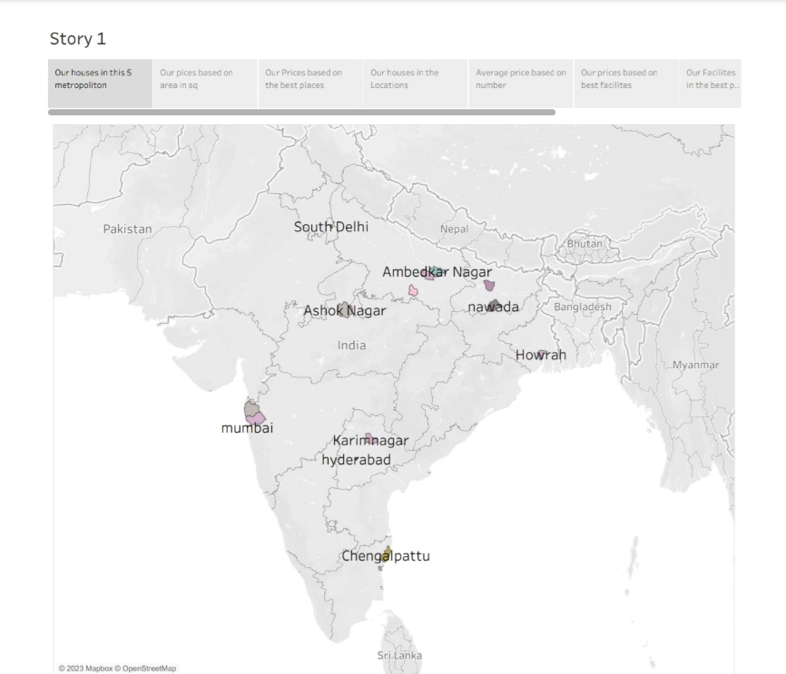l estate market conditions in a particular metropolitan area.

